Title: **Biodiversity conservation in an uncertain world**

Authors: Richard Schuster a,b,*, Rachel Buxtona, Jeffrey O. Hansona, Allison D. Binleya, Jeremy Pittmanc, Vivitskaia Tullochd, Frank A. La Sortee, Raquel Garciaf, Peter H. Verburgg, Amanda D. Rodewalde,h, Scott Wilsona,i, Peter Arcesed, Hugh Possinghamj,k, Joseph R. Bennetta

Affiliations:

a Department of Biology, 1125 Colonel By Drive, Carleton University, Ottawa ON, K1S 5B6 Canada.

b Ecosystem Science and Management Program, 3333 University Way, University of Northern British Columbia, Prince George BC, V2N 4Z9 Canada.

cSchool of Planning, University of Waterloo, 200 University Ave W, Waterloo, ON, N2T 3G1, Canada

d Conservation Decisions Lab, Department of Forest and Conservation Sciences, 2424 Main Mall, University of British Columbia, Vancouver BC, V6T 1Z4 Canada.

e Cornell Lab of Ornithology, Cornell University, Ithaca, NY 14850, USA

f Centre for Invasion Biology, Dept of Botany and Zoology, Stellenbosch Univ, South Africa

g Institute for Environmental Studies, VU University Amsterdam, Amsterdam, The Netherlands

h Department of Natural Resources and the Environment, Cornell University, Ithaca, NY 14853, USA.

i Wildlife Research Division, Environment and Climate Change Canada, 1125 Colonel By Drive, Ottawa, Ontario, Canada, K1S 5B6

j Centre for Biodiversity and Conservation Science, University of Queensland, St Lucia, Queensland, Australia

k The Nature Conservancy, Arlington, Virginia

*Corresponding author: Department of Biology, 1125 Colonel By Drive, Carleton University, Ottawa ON, K1S 5B6 Canada. Email: [richard.schuster@glel.carleton.ca](mailto:richard.schuster@glel.carleton.ca), Phone: +1 250 631 8324, ORCID: 0000-0003-3191-7869

**First paragraph**

Curbing biodiversity loss in a rapidly changing global environment is one of the great challenges of the 21st Century1,2. As climate and land-cover change intensify, their impacts on biodiversity and conservation response will be mediated by governance3,4, requiring targeted investment in projects that consider risk of failure under changing conditions. Protected areas are a key instrument in efforts to conserve biodiversity, yet increasing pressure from poor governance, land-use intensification5, and climate6 change risk reducing protected area effectiveness. Here we show that incorporating these risks into conservation plans requires only small (1%) increases in land area to protect 30% of the world’s terrestrial vertebrates. Although the same 3.57 million km2  of land was identified as priority habitat across all scenarios, the effectiveness of governance drove variation in the location and amount of land prioritized. In particular, conserving wide-ranging species required countries to protect more land when bordering nations with relatively weak governance. These areas may be priorities for developing protected area networks that are resilient to multiple aspects of anthropogenic change. Our results suggest that these sources of risk can feasibly be accounted for in global protected area planning and emphasize the importance of cross-jurisdictional conservation planning.

**Main text**

Protecting habitat is one of the best strategies for stemming the alarming loss in biodiversity7. As such, the cornerstone of the renewed global framework for biodiversity conservation aims to protect at least 30% of terrestrial land area by 20308. To identify areas of particular importance for biodiversity for inclusion in the expanding protected area network, current approaches rely on measures of regional biodiversity value and vulnerability8–10. Current conservation policy thus assumes that protected areas are permanent and their effectiveness is static. However, governance, land use intensification, and climate change pose risks to the future effectiveness of protected areas. For example, the quality of governance predicts investment in conservation4,11 while political instability and corruption can reduce protected area effectiveness12, protected areas with more deforestation are at high risk of degazetting and project failure13, and increased extreme weather events cause population decline or extirpation for a variety of species14. Thus, to make effective use of limited conservation resources, planning for investment in protected areas must account for these risks to safeguard against uncertainty in conservation outcomes and potential future biodiversity loss15. We quantify how accounting for governance, land-use, and climate risks can influence decisions for protected area establishment at a global scale. We show how accounting for these risks can identify key areas that may be most resilient to future change, buffering biodiversity against risk.

We consider three broad categories of risk, which we define as pressures that increase the likelihood that protected areas will become ineffective for protecting biodiversity under future conditions: i) governance, ii) land-use, and iii) climate impacts. For governance, we use a national-scale metric that combines six governance indicators from the World Bank16: accountability, political stability, government effectiveness, regulatory quality, rule of law, and control of corruption (Figure S1). For land-use, we estimated the average change in biodiversity per land-use category using methods17 that model the risk of biodiversity loss for land systems due to agricultural expansion and intensification (Figure S2). For climate impacts, we use the duration of extreme heat events, calculated using a probabilistic framework that estimates the novelty of temperatures relative to historical year-to-year variation from 1948 to 2018 (Figure S3), identifying areas where heat events are likely to have the most significant effects on biodiversity18. We note that our specific metrics of risk are intended as examples, used to demonstrate the importance of considering governance, land use and climate change in combination. However, our approach is flexible and could incorporate other risk metrics with implications for biodiversity19.

We consider the influence of risk categories on allocating protection decisions at a global scale for all 30,930 known distributions of vertebrate species from the IUCN Red List of Threatened Species20 using a multi-objective optimization approach. To incorporate risk categories, we built on a classical problem formulation from the systematic conservation planning literature21,22. We use the minimum set problem, where the goal is to minimize the cost of a solution, defined here as total protected area, while reaching feature targets23. We expand this approach to include multiple objectives accounting for varying risk in the problem formulation24. We use a hierarchical or lexicographic approach that assigns a priority to each objective, and optimizes for the objectives in decreasing priority order. At each step, the approach finds the best solution for the current objective, but only from among those that would not degrade the solution quality for higher-priority objectives.

Because of the hierarchical structure, we created 16 planning scenarios, with solutions that account for different combinations of risk categories in each level of the hierarchy (Table S1). We then compared solutions with risks incorporated to a baseline scenario, representing the classical area-based approach to solving conservation planning problems23. Because our scenarios were aimed at building on the current protected area portfolio globally, we incorporated current protected areas into our solutions. For each scenario we set a 30% distribution area protection target for all vertebrate species, which we use as an example that is broadly analogous to the more general 30% total area Convention on Biological Diversity (CBD) target25. Currently, 17.2% of the global terrestrial area is protected. To investigate the effects of including our three risk categories, we compared the spatial representation among scenarios incorporating risk to baseline at the global and country scale.

We found that the protected areas planning scenarios incorporating the three risk categories required only 0.9% more global area on average (0.34 – 1.14 %) than the baseline scenario to meet the target of protecting 30% of vertebrate habitat. Thus, accounting for key risks to protected area effectiveness to produce more resilient conservation networks will not substantially increase the global area required to meet 30% protection targets. Additionally, we found that all 16 scenarios reached their goals of 30% protection of each vertebrate species range without surpassing the 30% global area target that the CBD is currently considering in their post-2020 framework. Of all scenarios, those including land-use change required the greatest increase in global protected area, compared to scenarios only including governance and/or climate extremes (Table S1).

There was also considerable spatial overlap among scenarios, with the same 22 million km2 (6.9% of global land area) being selected to expand the current protected area portfolio in at least eleven scenarios and 3.6 million km2 (2.4% of global land area) in all fifteen risk scenarios. Such overlaps provide examples of areas that could be targets for international agencies wishing to maximize the resilience of protected area networks, as they are robust to assumptions of relative importance of risk factors. Example countries that have contiguous areas of high overlap among scenarios are Canada, Egypt, Finland, Kazakhstan and Peru (Figure S4). There is some overlap among scenarios within global biodiversity hotspots26, but a considerable percentage of high overlap among scenario areas lie either outside these hotspots (83.1%) or occur within small portions of these areas (Figure S5).

However, we found substantial variation in some countries in the amount of area requiring protection between risk and baseline scenarios (Fig. 1; Table S2). These differences were driven largely by governance (Fig. 2). Countries with higher governance scores had greater area requiring protection under risk scenarios versus baseline, especially when species were wider ranging and when neighboring countries had lower governance scores. Thus, risk is connected across jurisdictions, where planning scenarios favor protection of species in nearby countries with low governance risk. For example, many vertebrate species ranges span north-eastern Russia, Finland, and Sweden, with one of the most iconic being caribou (*Rangifer tarandus*), which has an IUCN conservation status of vulnerable. Because Russia suffers from poor ‘voice and accountability, rule of law, and control of corruption’ (Table S3), whereas Finland and Sweden have relatively high governance scores, the scenarios including governance pressures led to a selection of 99.4% and 48.9% of Finland and Sweden’s land areas compared to the baseline scenario with 30.8% and 15.2%. These results do not suggest to literally set aside all of Finland, but indicate that prioritizing areas in Sweden and Finland is predicted to be far less of a risk than areas in Russia.

Land-use and climate change also influenced variation in areas requiring protection above baseline. For example, large areas of Sierra Leone are experiencing high risk of biodiversity loss due to intense land-use practices (Fig. S2), whereas this same risk is lower in neighboring Liberia. Scenarios including land-use risk selected 50.1% of the land area in Liberia compared to 21.9% in the baseline scenario. Large areas of Saudi Arabia are experiencing increasingly frequent extreme heat events (Fig. S3), whereas neighboring United Arab Emirates have been largely buffered by proximity to two major gulfs. Scenarios including climate have a selection of 38.2% in the United Arab Emirates land areas compared to the baseline scenario with 25.1%.These results emphasize the importance of coordinated cross-jurisdictional conservation planning initiatives27 and identify countries where opportunities for collaboration would yield more resilient protected areas. An example species is the endangered Great Green Macaw (*Ara ambiguus*), with <2500 individuals remaining. Its range stretches from southern Honduras to western Colombia and crosses a number of countries differing in political stability, land use, and climate effects. Coordinated efforts between countries could help in the species’ persistence into the future. For countries with a predominance of wide-ranging species whose ranges will be impacted by varying climate, land-use, and governance risk across borders, conservation projects can focus on cooperative governance frameworks28.

In contrast, countries at high risk from climate change, land-use, and poor governance, especially those with high endemism, for example in northern Oceania, have a low difference between scenarios that incorporate risk versus baseline. Given high and endemic biodiversity, and homogeneity of risk, these countries will require high rates of protection within their own borders. Moreover, some countries closer to reaching the CBD’s 30% land area protection target, for example Brazil, which already has 30.3% of its land area protected, had lower differences between scenarios that incorporate risk versus baseline, despite having high climate, land-use, and governance risk. This outlines the importance of further considering the effectiveness of existing protected areas in planning analyses, where pressure from cropland conversion in tropical protected areas has increased to similar rates outside protected areas29.

Our framework is flexible, allowing conservation agencies looking to set priorities from the global to local scale and incorporate different metrics, examining the influence of each metric according to its assumed relative importance. Previous work has incorporated risk factors analogous to those we used, including governance [citations from above], climate change [citations from above] and land-use change [citations]. Yet, our results show that protected area expansion decisions can be profoundly influenced by all three factors. Where data on these or other factors that may alter the effectiveness of biodiversity protection are available and reasonably reliable, we argue that they should be used together to support decisions for resilient protected area networks. Our framework and methods can allow management agencies to do so, and also explore the influence of individual parameters on decisions.

**Conclusion**

Despite the expansion of the protected area network in the past few decades, biodiversity has continued to decline, largely due to intensifying land-use and climate change and varying quality of governance, which results in different levels of commitment to conservation among jurisdictions. As conservation agencies look to secure new areas for protection, risk of future change will be particularly important as projected changes in climate (citation from below), land-use (citation from below), and socio-economic uncertainty can compromise protected area effectiveness. Our results show that protected area expansion decisions can be profoundly influenced by risk, particularly governance, but that considering risk is achievable, only adding <1% to the total global area required to meet biodiversity targets. Our results also emphasize the importance of cross-jurisdictional conservation initiatives, especially in adjacent countries sharing wide-ranging species where risk factors predominate. Considering risk in conservation decision-making will lead to more resilient and effective conservation plans into the future to help safeguard our planet’s biodiversity in the face of the current extinction and climate crises.

**Main references**

1. Brondizio, E. S., Settele, J., Díaz, S. & Ngo, H. T. Global assessment report on biodiversity and ecosystem services of the Intergovernmental Science-Policy Platform on Biodiversity and Ecosystem Services. *IPBES Secretariat* (2019).

2. Rosenberg, K. V. *et al.* Decline of the North American avifauna. *Science* **366**, 120–124 (2019).

3. Eklund, J. F. & Cabeza-Jaimejuan, M. D. M. Quality of governance and effectiveness of protected areas: crucial concepts for conservation planning. *Annals of the New York Academy of Sciences* (2017).

4. Baynham-Herd, Z., Amano, T., Sutherland, W. J. & Donald, P. F. Governance explains variation in national responses to the biodiversity crisis. *Environmental Conservation* **45**, 407–418 (2018).

5. Pouzols, F. M. *et al.* Global protected area expansion is compromised by projected land-use and parochialism. *Nature* **516**, 383–386 (2014).

6. Hoffmann, S., Irl, S. D. & Beierkuhnlein, C. Predicted climate shifts within terrestrial protected areas worldwide. *Nature communications* **10**, 1–10 (2019).

7. Watson, J. E. M., Dudley, N., Segan, D. B. & Hockings, M. The performance and potential of protected areas. *Nature* **515**, 67–73 (2014).

8. Zero draft of the post-2020 global biodiversity framework.

9. Brooks, T. M. *et al.* Global biodiversity conservation priorities. *science* **313**, 58–61 (2006).

10. Venter, O. *et al.* Targeting Global Protected Area Expansion for Imperiled Biodiversity. *PLOS Biology* **12**, e1001891 (2014).

11. Miller, D. C., Agrawal, A. & Roberts, J. T. Biodiversity, governance, and the allocation of international aid for conservation. *Conservation Letters* **6**, 12–20 (2013).

12. Schulze, K. *et al.* An assessment of threats to terrestrial protected areas. *Conservation Letters* **11**, e12435 (2018).

13. Tesfaw, A. T. *et al.* Land-use and land-cover change shape the sustainability and impacts of protected areas. *Proceedings of the National Academy of Sciences* **115**, 2084–2089 (2018).

14. Maxwell, S. L. *et al.* Conservation implications of ecological responses to extreme weather and climate events. *Diversity and Distributions* **25**, 613–625 (2019).

15. McBride, M. F., Wilson, K. A., Bode, M. & Possingham, H. P. Incorporating the effects of socioeconomic uncertainty into priority setting for conservation investment. *Conservation Biology* **21**, 1463–1474 (2007).

16. Kaufmann, D., Kraay, A. & Mastruzzi, M. The Worldwide Governance Indicators: Methodology and Analytical Issues1. *Hague Journal on the Rule of Law* **3**, 220–246 (2011).

17. Kehoe, L. *et al.* Biodiversity at risk under future cropland expansion and intensification. *Nature Ecology & Evolution* **1**, 1129–1135 (2017).

18. La Sorte, F. A., Johnston, A. & Ault, T.R. Global trends in the frequency and duration of temperature extremes. Climatic Change, *In review*.

19. Garcia, R. A., Cabeza, M., Rahbek, C. & Araújo, M. B. Multiple dimensions of climate change and their implications for biodiversity. *Science* **344**, 1247579 (2014).

20. IUCN. The IUCN Red List of Threatened Species. version 1.18. (2019).

21. Margules, C. R. & Pressey, R. L. Systematic conservation planning. *Nature* **405**, 243–53 (2000).

22. Moilanen, A., Wilson, K. A. & Possingham, H. P. *Spatial conservation prioritization: quantitative methods and computational tools*. vol. 6 (Oxford University Press Oxford, UK, 2009).

23. Ball, I. R. R., Possingham, H. P. P. & Watts, M. E. E. Marxan and relatives: Software for spatial conservation prioritisation. in *Spatial conservation prioritisation: Quantitative methods and computational tools.* (eds. Moilanen, A., Wilson, K. & Possingham, H. P.) 185–195 (Oxford University Press, 2009).

24. Deb, K. Multi-objective optimization. in *Search methodologies* 403–449 (Springer, 2014).

25. Post-2020 Global Biodiversity Framework. *IUCN* https://www.iucn.org/theme/global-policy/our-work/convention-biological-diversity-cbd/post-2020-global-biodiversity-framework (2018).

26. Myers, N., Mittermeier, R. A., Mittermeier, C. G., da Fonseca, G. A. B. & Kent, J. Biodiversity hotspots for conservation priorities. *Nature* **403**, 853–858 (2000).

27. Dallimer, M. & Strange, N. Why socio-political borders and boundaries matter in conservation. *Trends in Ecology & Evolution* **30**, 132–139 (2015).

28. Miller, R. L., Marsh, H., Benham, C. & Hamann, M. A framework for improving the cross-jurisdictional governance of a marine migratory species. *Conservation Science and Practice* **1**, e58 (2019).

29. Geldmann, J., Manica, A., Burgess, N. D., Coad, L. & Balmford, A. A global-level assessment of the effectiveness of protected areas at resisting anthropogenic pressures. *Proceedings of the National Academy of Sciences* **116**, 23209–23215 (2019).

30. Eisenhauer, N., Bonn, A. & A. Guerra, C. Recognizing the quiet extinction of invertebrates. *Nature Communications* **10**, 1–3 (2019).

31. Le Saout, S. *et al.* Protected areas and effective biodiversity conservation. *Science* **342**, 803–805 (2013).

32. Butchart, S. H. M. *et al.* Shortfalls and Solutions for Meeting National and Global Conservation Area Targets. *Conservation Letters* **8**, 329–337 (2015).

33. Planet, P. Calculating protected area coverage. *Protected Planet* https://www.protectedplanet.net/c/calculating-protected-area-coverage.

34. Coetzer, K. L., Witkowski, E. T. & Erasmus, B. F. Reviewing B iosphere R eserves globally: effective conservation action or bureaucratic label? *Biological Reviews* **89**, 82–104 (2014).

35. Barnes, M. D. *et al.* Wildlife population trends in protected areas predicted by national socio-economic metrics and body size. *Nature Communications* **7**, 12747 (2016).

36. Asselen, S. van & Verburg, P. H. A Land System representation for global assessments and land-use modeling. *Global Change Biology* **18**, 3125–3148 (2012).

37. Hudson, L. N. *et al.* The PREDICTS database: a global database of how local terrestrial biodiversity responds to human impacts. *Ecology and Evolution* **4**, 4701–4735 (2014).

38. Newbold, T. *et al.* Global effects of land use on local terrestrial biodiversity. *Nature* **520**, 45–50 (2015).

**Figure legends (+ figures)**

Figure 1: Percent country-level variation between the base scenario and the 15 scenarios including risk. Countries whose results are consistent across the 15 scenarios (e.g. Brazil) have low variation, while countries whose results are less consistent across the 15 scenarios have high variation (e.g. Sweden).

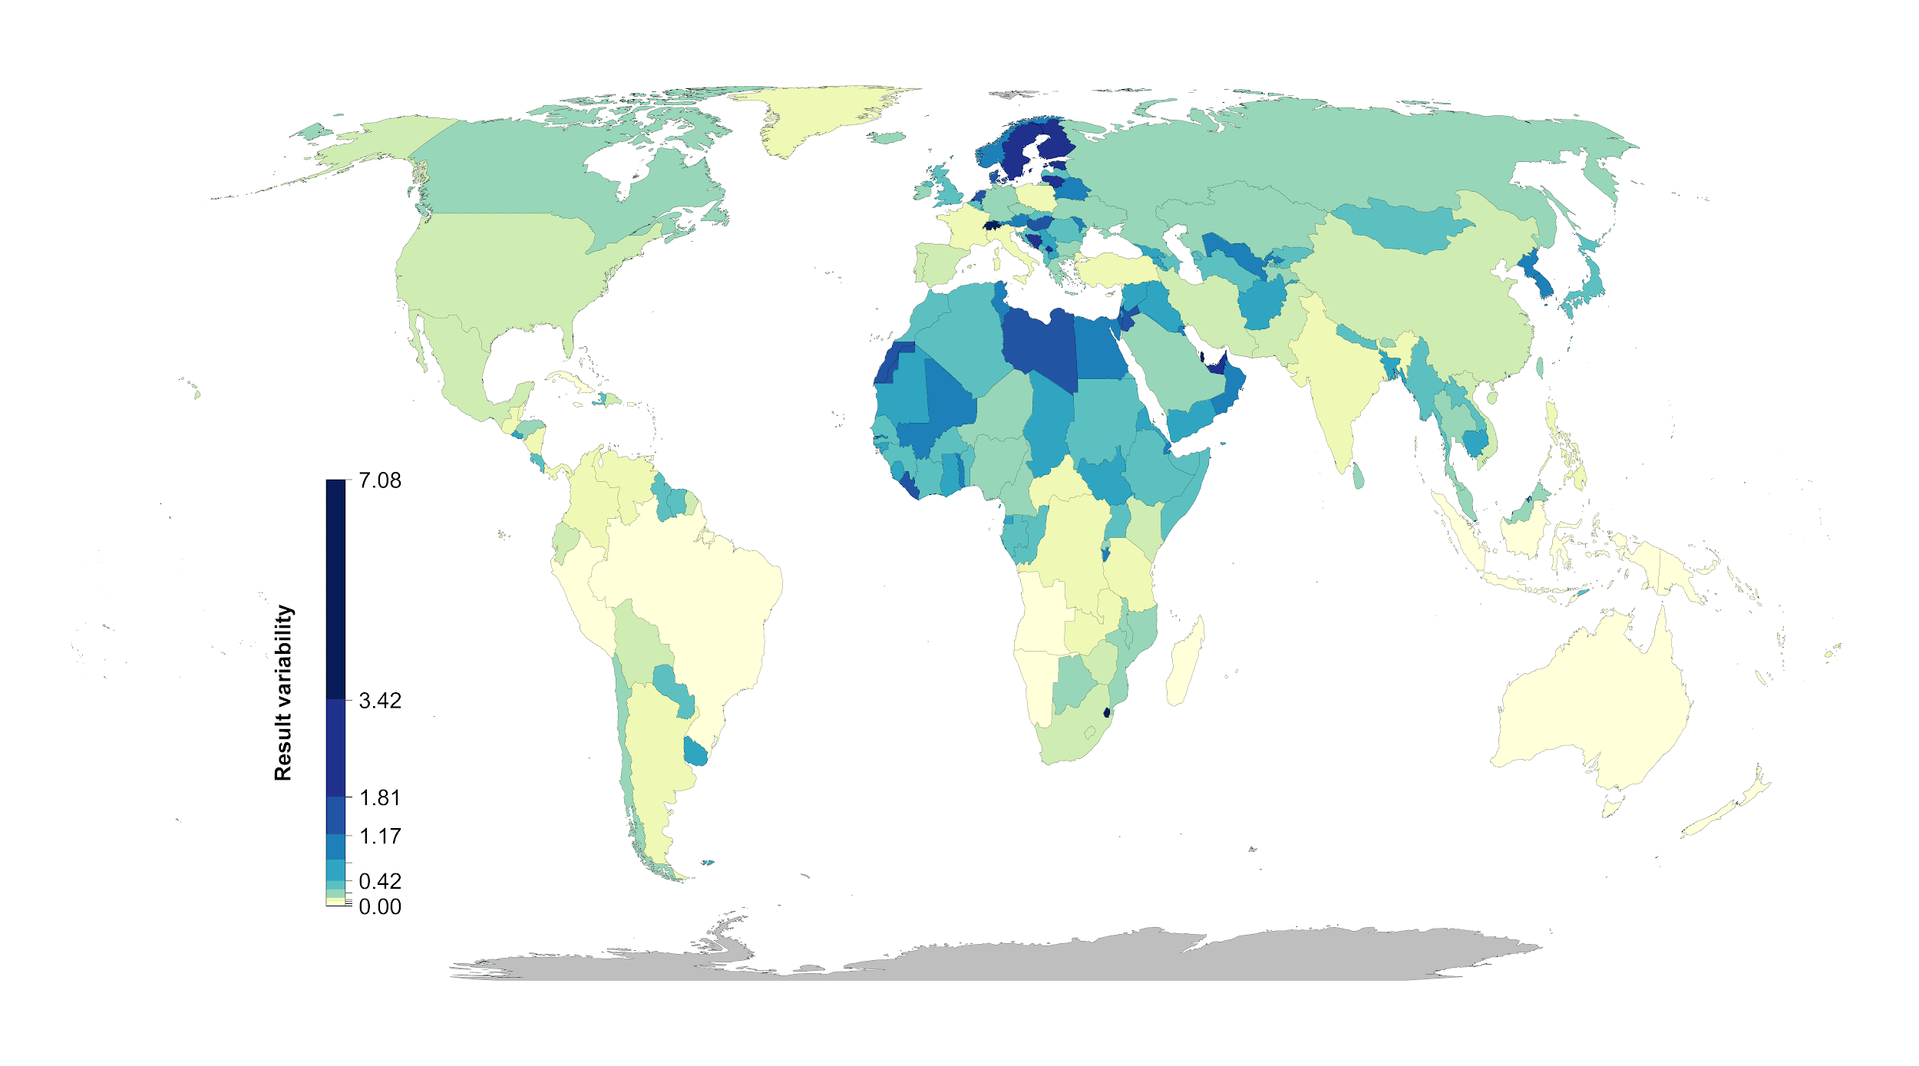

Figure 2: Influence of average country specific risk factors on the optimization outcomes compared between baseline scenario and the scenario including one of the risk factors. Each data point represents the results for one country. The fitted blue lines and 95% confidence bands are from ordinary least-squares regression.

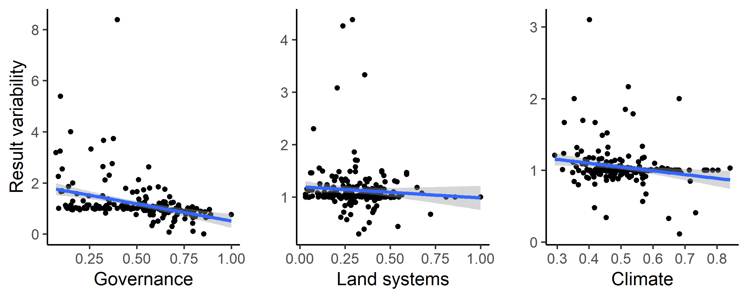

**Methods**

We used a multi-objective optimization approach that incorporated governance, land use and climate constraints to prioritize the conservation of 30,930 vertebrate species. All scenarios we investigated were built on the current global protected area portfolio. We further set a target to protect 30% of the range of each species, which is broadly analogous to current CDB discussions on post-2020 biodiversity targets8.

*Species selection*

Our species list included all terrestrial vertebrate species from the IUCN Red List of threatened species, following Pouzols et al.5. For mammal, amphibian and reptile species ranges, we used the IUCN Red List website (<http://www.iucnredlist.org/>, accessed 2019-11-14) and for birds we used the BirdLife International data zone webpage (<http://www.birdlife.org/datazone/home>, accessed 2019-11-14). We used these taxa because no analogous data are available for a lower proportion of species in other taxonomic groups such as insects30. These data have certain limitations, including possible underestimation of the extent of occurrence and overestimation of the true area of occupancy5, but have been shown to be robust to commission errors as long as the focus is on species assemblages rather than single species 10. They are currently the most frequently used and updated source for vertebrate species distributions31.

For each taxonomic group, we restricted our analysis to species that fell into the presence category of ‘Extant’, the origin categories of ‘Native’ or ‘Reintroduced’ and the seasonality categories ‘Resident’, ‘Breeding Season’ or ‘Non-breeding Season’, thus only focusing on stationary periods of the life cycle of migratory species. This resulted in the following final numbers of amphibian, bird, mammal and reptile species ranges: 5660, 13375, 5442, and 6153, respectively.

*Basic administrative delineations*

National boundaries were derived from the Global Administrative Areas database (<http://gadm.org/>, accessed 2019-10-31). We obtained protected area boundaries from the World Database on Protected Areas (WDPA, [https://www.protectedplanet.net](https://www.protectedplanet.net/)). Following standard procedures for cleaning the protected area dataset32,33, we (i) projected the data to an equal-area coordinate system (World Behrman), (ii) excluded reserves with unknown or proposed designations, (iii) excluded UNESCO Biosphere Reserves34, (iv) buffered sites represented as point localities to their reported area, (v) dissolved boundaries to prevent issues with overlapping areas, and (vi) removed slivers (code available at https://github.com/jeffreyhanson/global-protected-areas). After the protected area data were modified as described above, we overlaid the protected area boundaries with a 10 x 10 km grid covering the Earth. These spatial data procedures were implemented using ArcMap (version 10.3.1) and python (version 2.7.8).

*Governance risk*

Conservation risk due to governance can affect the outcomes of strategies, and effective governance can promote the resilience of conservation in the face of sociopolitical and economic shocks. We used worldwide governance indicators from the World Bank16 to capture these pressures. The indicators include six scaled measures: voice and accountability; political stability and absence of violence; government effectiveness; regulatory quality; rule of law; and control of corruption (see Table S4 for definitions). We chose these indicators because evidence suggests that they reliably predict protected area effectiveness35 and state investment and efforts for biodiversity conservation4. For each country, we used a mean of annual averages of all six measures4 (Figure S1).

*Land use risk*

We used a recently developed global land systems map produced by Kehoe et al.17 to incorporate the risk of land-use change. This map is based on a global land systems map for the year 200036 at a 9.25 km2 spatial resolution, but is refined based on recent land-cover and land-use datasets to a spatial resolution of 1 km2. Kehoe et al.17 further estimated the impact of land use and land use intensity on biodiversity, with data originating from the PREDICTS project37. They first matched their land-systems classes to varying intensity levels for each land-use type (for detailed conversion table, see ref38). This allowed Kehoe et al.17 to calculate average biodiversity loss per land system (relative to an unimpacted baseline) by taking the mean model estimates of biodiversity loss per land-use intensity class from previous work38. The result gives average relative biodiversity gain or loss per land-system class. Here, we used their modelled mean estimates (following Newbold et al.38) of relative percent biodiversity change for each land-system class for species abundance as a measure of the land-use pressure (Figure S2).

*Climate risk (text largely adopted from Frank’s paper)*

There is evidence that the increased exposure to extreme heat events (EHE) adversely affects human populations (Anderson & Bell Michelle, 2011; Battisti & Naylor, 2009; Guo et al., 2017; Mitchell et al., 2016) and natural systems within terrestrial (Harris et al., 2018; Maxwell et al., 2019) and marine environments (Garrabou et al., 2009; Wernberg et al., 2013). How the frequency and duration of EHE has changed over time has been explored primarily within terrestrial regions during the boreal and austral summers (Coumou & Robinson, 2013; Oswald, 2018), but there are examples that have considered other seasons of the year (Alexander et al., 2006). There are a number of climate indices that have been used to estimate the occurrence of extreme heat events (Fenner et al., 2019; Smith et al., 2013). These climate indices are often context specific and there is little consensus on the most appropriate technique (McPhillips et al., 2018). Here, we define the occurrence of extreme heat events using a probabilistic framework that estimates the novelty of each event relative to historical year-to-year variation in temperature at each location. Specifically, we use detrended daily measures of minimum and maximum temperature to estimate when and where temperatures significantly exceed historical variation in temperature over a 71-year period (1948 to 2018). This approach provides a standardized measure of the novelty of climate extremes that allows for valid comparisons across space and time. We use this approach to determine how the frequency and duration of EHE have changed over time and the regions and seasons where these events are likely to have the most significant effects on natural systems and human populations now and into the future.

The metric we used here is the duration of each event within each year and pixel based on the number of consecutive days containing EHE. We extracted the maximum continuous duration of each event for each year and pixel. We selected the maximum because it provided improved distributional properties for analysis and identifies the most significant event for each year. We averaged the maximum duration of each event within each pixel across the 71-year period. We modeled the change in the maximum duration in each event over the 71-year period using Poisson regression (Lambert, 1992).

Figure S3

*Multi-objective optimization of pressure reduction*

We processed all data described previously to a 10 x 10 km resolution and clipped data to the extent of land based on the global administrative areas database.

We then developed an extension on the minimum set problem, which has the goal to identify a set of sites within a planning area that represents all conservation targets in the fewest number of sites21. Instead of including one objective we expanded the formulation to include multiple objectives in the problem formulation. We used a hierarchical or lexicographic approach that assigns a priority to each objective, and optimizes for the objectives in decreasing priority order. At each step, it finds the best solution for the current objective, but only from among those that would not degrade the solution quality for higher-priority objectives. We considered up to three objectives in our prioritization scenarios, i) governance risk, ii) land-use risk, and iii) climate risk. To compare different scenarios, we calculated solutions for each unique objective combination (n = 15), as well as one where we use a constant objective function as the base scenario.

**We should probably add the maths in here. Jeff, would you be able to do that?**

For all scenarios we locked in current protected areas and used the same feature set of 30,930 vertebrates. The target for each feature was set to 30% of their range. The optimality gap we use was 5% for each objective in the hierarchy. As the order of the hierarchy can influence the results, we ran all possible combinations and orders of the three risk factors for a total of 15 scenarios.

**Methods references**

**Acknowledgements**

V. Tulloch was supported by a Postdoctoral Research Grant from Environment and Climate Change Canada.

**Author contributions**

**Competing interest declaration**

**Table S1.** Scenarios explored and global protection results. The risk factor order represents the order risk factors were included in the hierarchical prioritization. (G = governance, L = land use, C = Climate).

|  |  |  |
| --- | --- | --- |
| **Scenario** | **Risk factors included** | **Global land area protected [%]** |
| **baseline** | - | 28.08 |
| **1** | G | 28.44 |
| **2** | L | 29.23 |
| **3** | C | 28.45 |
| **4** | G > L | 29.2 |
| **5** | L > G | 29.23 |
| **6** | G > C | 28.43 |
| **7** | C > G | 28.45 |
| **8** | L > C | 29.19 |
| **9** | C > L | 29.19 |
| **10** | G > L > C | 29.17 |
| **11** | G > C > L | 29.2 |
| **12** | L > G > C | 29.19 |
| **13** | L > C > G | 29.19 |
| **14** | C > G > L | 29.2 |
| **15** | C > L > G | 29.19 |

**Table S2**. Country specific results for the 15 scenarios investigated. Numbers represent % of land area of a country selected.  
(As an example 5 countries included here, full list in csv)   
<https://drive.google.com/file/d/1eD4y4K8XG4nxnRL5fNtiTqzuqfIJ_DfB/view?usp=sharing>

|  |  |  |  |  |  |
| --- | --- | --- | --- | --- | --- |
|  | Afghanistan | Akrotiri and Dhekelia | Åland | Albania | Algeria |
| A | 22.99 | 50 | 0 | 19.1 | 32.65 |
| S | 15.93 | 100 | 100 | 17.36 | 20.54 |
| L | 26.65 | 50 | 33.33 | 21.88 | 29.8 |
| C | 23.1 | 50 | 0 | 19.79 | 27.53 |
| SL | 26.58 | 50 | 8.33 | 21.88 | 30.01 |
| LS | 26.58 | 50 | 25 | 21.88 | 29.81 |
| SC | 15.93 | 50 | 58.33 | 17.36 | 21.03 |
| CS | 23.1 | 50 | 0 | 19.79 | 27.53 |
| LC | 26.54 | 50 | 16.67 | 21.18 | 30.84 |
| CL | 26.58 | 50 | 0 | 21.88 | 30.78 |
| SLC | 26.52 | 50 | 8.33 | 21.53 | 30.88 |
| SCL | 26.57 | 50 | 0 | 21.88 | 30.69 |
| LSC | 26.54 | 50 | 16.67 | 21.18 | 30.84 |
| LCS | 26.54 | 50 | 16.67 | 21.18 | 30.84 |
| CSL | 26.55 | 50 | 0 | 21.88 | 30.76 |
| CLS | 26.58 | 50 | 0 | 21.88 | 30.78 |

**Table S3. Governance risk score table (see csv)**<https://drive.google.com/file/d/1g_LePBfCbphXzTiCOXCzQtNLSSYoV6me/view?usp=sharing>

**Table S4.**

|  |  |
| --- | --- |
| **Indicator** | **Definition**  Source: World Bank, 2020 (<https://datacatalog.worldbank.org/dataset/worldwide-governance-indicators>) |
| Voice and accountability | “Voice and accountability captures perceptions of the extent to which a country's citizens are able to participate in selecting their government, as well as freedom of expression, freedom of association, and a free media.” |
| Political stability and absence of violence | “Political Stability and Absence of Violence/Terrorism measures perceptions of the likelihood of political instability and/or politically-motivated violence, including terrorism.” |
| Government effectiveness | “Government effectiveness captures perceptions of the quality of public services, the quality of the civil service and the degree of its independence from political pressures, the quality of policy formulation and implementation, and the credibility of the government's commitment to such policies.” |
| Regulatory quality | “Regulatory quality captures perceptions of the ability of the government to formulate and implement sound policies and regulations that permit and promote private sector development.” |
| Rule of law | “Rule of law captures perceptions of the extent to which agents have confidence in and abide by the rules of society, and in particular the quality of contract enforcement, property rights, the police, and the courts, as well as the likelihood of crime and violence.” |
| Control of corruption | “Control of corruption captures perceptions of the extent to which public power is exercised for private gain, including both petty and grand forms of corruption, as well as "capture" of the state by elites and private interests.” |

**Figure S1. Governance risk (yellow = low, red = high)**

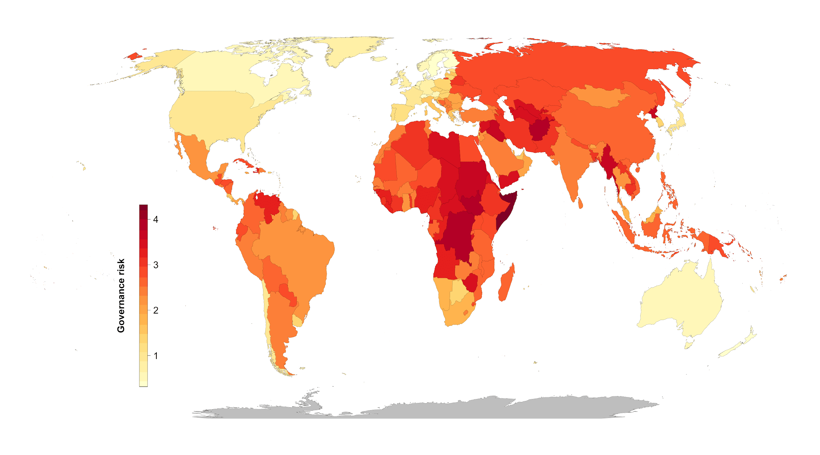

**Figure S2. Land use risk (yellow = low, red = high)**

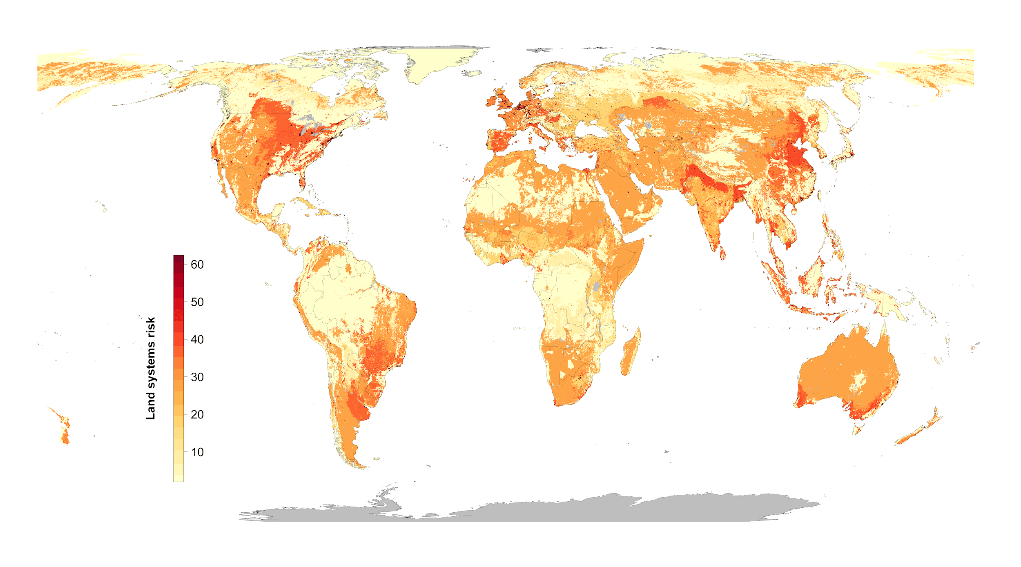

**Figure S3. Climate risk (extreme heat events) (yellow = low, red = high)**

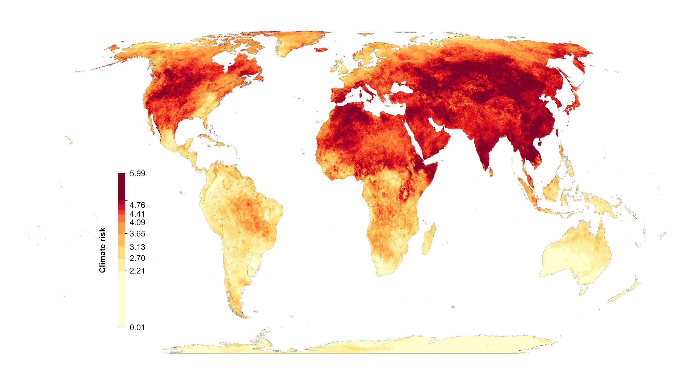

**Figure S4. Areas of high scenario overlap (>10 scenarios, green) compared to Meyers et al. biodiversity hotspots (blue).**

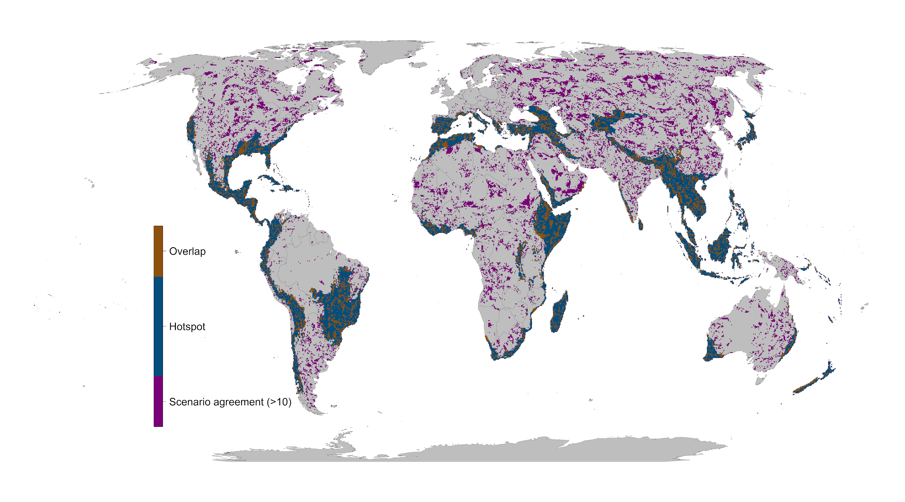

**Figure S5: Scenario overlap. green = protected areas. Color gradient from yellow (one scenario) to red (15 scenarios) = ovelap.**

